Гуманитарный проект государственного учреждения «Ивацевичский территориальный центр социального обслуживания населения» Брестской области ищет спонсоров
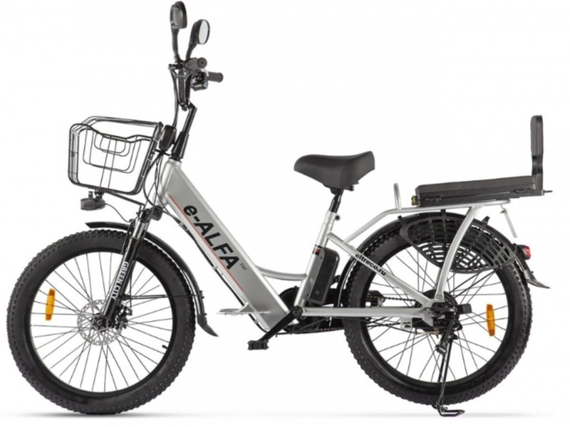

1 | Project name | «Always ready»
2 | Name of organization | State Institution "Ivatsevichi Territorial Center for Social Services of the Population"
3 | Address of the organization, phone number | Brest region, Ivatsevichi, Shcorsa str., 13,  225295 Index  E-mail Ivtcson@brest.by  Fax :+375164597689  Phone:+3751645 30077
4 | Information about the organization | The State Institution "Ivatsevichi Territorial Center for Social Services to the Population" was established by the decision of the district executive committee № 624 dated 11.18.2003 in order to fulfill state social standards in the field of social services to the population.  The purpose of the center is to carry out on the territory of the Ivatsevichi district organizational, methodological and practical activities for the social service of citizens in difficult life situations. Our categories: single elderly citizens, disabled people, families raising disabled children, large families, orphans, dysfunctional families, low-income citizens.
5 | Head of the organization | Pokalyuk Denis, Director of the State Institution "Ivatsevichi Territorial Center for Social Service of the Population"  Tel:+3751645 25319  E-mail Ivtcson@brest.by
6 | Project Manager | Herman Elena Alexandrovna,  Head of the Department of Social Assistance at Home State Institution "Ivatsevichi Territorial Center for Social Services to the Population"  Phone 8 01645 25092, +375295218946  e-mail: germanal_an@mail.ru
7 | Previous assistance received from other foreign sources | in 2022: financial support from the Embassy of the Federal Republic of Germany in the Republic of Belarus as part of the "2+2" project
8 | Required amount | 10%
9 | Project term | May 2023 – August 2023
10 | Project Objective | Strengthening the material and technical base of the institution, improving the quality of life of the elderly and the disabled
11 | Objectives of the project | - strengthening the material and technical base of the state institution "Ivatsevichi Territorial Center for Social Services to the Population"  Labour rehabilitation of disabled persons;  - provision of social assistance to needy disabled and elderly citizens living in the territory of the Ivatsevichi district;  - improving the quality of social services provided;  - increasing the productivity of social workers;  - providing social workers with electric bikes;  - increasing the mobility of social workers in the provision of social services;  - increase in the number of citizens served in the department of social assistance at home.
12 | Detailed description of the activities within the framework of the project in accordance with the tasks | For the successful implementation of the project, it is necessary to purchase Green City E Alfa Fat electric bicycles in the amount of 10 pieces
13 | Justification of the project | Elderly citizens and disabled people living in rural areas are the category of the population that is the most socially unprotected, which needs special attention and social protection.  The main goal of the work of social workers is aimed at the maximum possible extension of the stay of the elderly and disabled in their usual home conditions, maintaining their social, psychological and physical status.  In its activities, the department faces the problem of organizing the provision of social services at home to elderly and disabled citizens living in remote and sparsely populated areas of the Ivatsevichi district. Every day, social workers have to overcome many kilometers. A significant part of the time for social workers is the road.  Thus, the purchase of electric bicycles for social workers will improve the standard of living of this category of citizens, namely: the timeliness, availability and quality of social services.
14 | Post-project activities | After the end of the project, the maintenance of electric bicycles will be carried out at their own expense.
15 | Project budget | 9800 EUR

