Humanitarian project of the state institution "Ivatsevichi Territorial Center for Social Services of the Population" of the Brest region is looking for sponsors
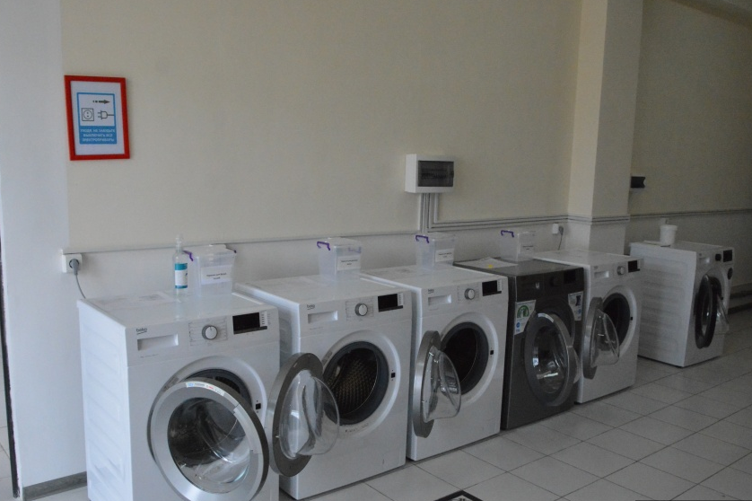

1 | Name of the project | «Big Wash»
2 | Name of the organization | State Institution "Ivatsevichi Territorial Center for Social Services of the Population"
3 | Organization address, phone number | Brest region, Ivatsevichi, Shchorsa str., 13,  225295  E-mail Ivtcson@brest. by  Fax :+375164597689  Tel:+3751645 30077
4 | Information about the organization | The purpose of the center is to carry out in the territory of the Ivatsevichi district organizational, methodological and practical activities for social services to citizens in difficult life situations. Our categories: lonely elderly citizens, disabled people, families raising disabled children, large families, orphans, dysfunctional families, low-income citizens.
5 | Head of Organization | Pokalyuk Denis, Director of the State Institution "Ivatsevichi Territorial Center for Social Services of the Population"  Tel:+3751645 25319  E-mail Ivtcson@brest. by
6 | Project Manager | Popko Olga  Head of the Department of Social Rehabilitation, Habilitation of The Disabled  Phone 8 01645 30077, +375 29 7681314  e-mail: popko.olga.86@mail.ru
7 | Previous assistance received from other foreign sources | In 2022: financial support from the Embassy of the Federal Republic of Germany in the Republic of Belarus within the framework of the "2 + 2" project
8 | Co-financing | 10% of the requested amount
9 | Project term | June 2023 – December 2023
10 | Purpose of the project | Opening of a social mini-laundry for the disabled and senior citizens
11 | Objectives of the project | - Provision of household services to needy citizens;  - Improving the quality of life of disabled and elderly citizens;  - increasing the volume of social services provided to the population;  - Creation of conditions for successful labor and social rehabilitation of disabled persons;  - Introduction of new areas of employment of persons with disabilities, expansion of the range of professional interests and inclinations;  - Creation of new jobs for persons with disabilities, employment of disabled persons;  - Strengthening the material and technical base of the institution.
12 | Detailed description of the activities within the framework of the project in accordance with the tasks | For the successful implementation of the project "Big Wash" and the opening of a mini-laundry it is necessary:  -purchase of 4 washing machines;  -purchase of 4 dryers.  -purchase of an iron;  -purchase of an ironing board.
13 | Rationale for the project | Not all pensioners can buy a washing machine, and people with disabilities cannot always wash themselves. The project is designed to improve the quality of life of the rural population by providing the necessary laundry services, which is vital.  The organization of the work of the mini-laundry will solve the urgent social problem of the lack of laundries in rural settlements of the Ivatsevichi district. Disabled and elderly citizens will be able to receive laundry services at socially low prices.  As part of the project, it is planned to open 3 mini-laundries for needy citizens in the Ivatsevichi district: in the branch of the center in Kossovo, in the branch of the center in telekhany and in Ivatsevichi. Social workers of our organization will be able to deliver laundry orders, which will allow us to massively expand the number of recipients of social services at home.  The opening of the workshop will have an economic and social effect through the creation of new jobs.
14 | Post-project activities | After the end of the project, the maintenance of household appliances will be carried out at its own expense
15 | Project Budget | 3650 euro

