Humanitarian social project for the acquisition of a 3D printer for the disabled in the branch of the State Institution "Ivatsevichi Territorial Center for Social Services of the Population" of the Brest Region is looking for sponsors
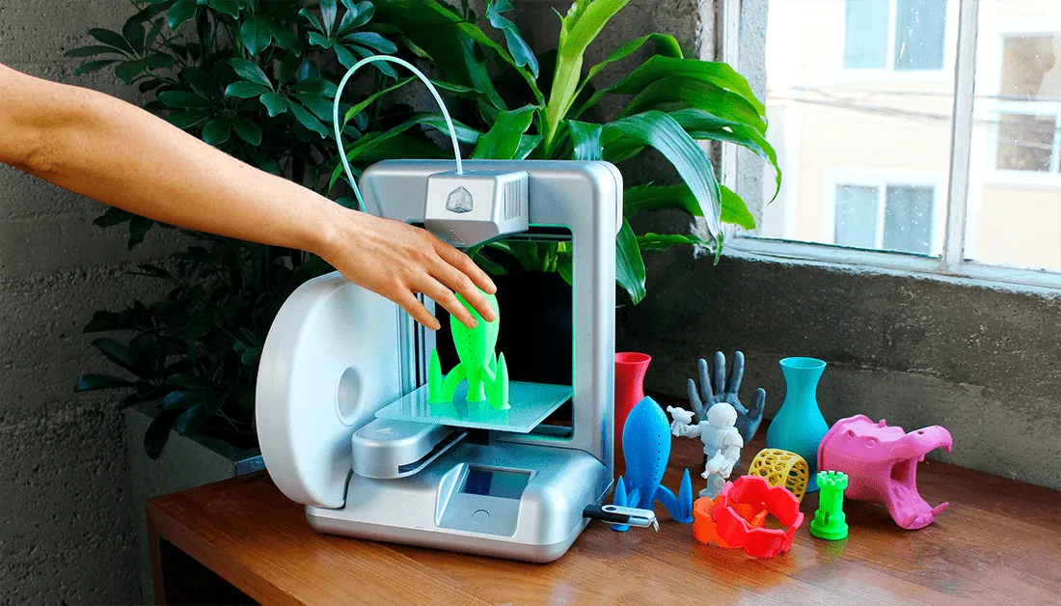

The goal of the project: Gaining new knowledge and skills for people with disabilities when working with a 3D printer. Mastering a new type of creative activity.

- Project name: " Futurama"

- Project implementation period: 1 year

- Applicant organization proposing the project: State institution "Ivatsevichi territorial center for social services to the population"
- Head of the organization: Elena Aleksandrovna German, Director of the State Institution “Ivatsevichy Territorial Center for Social Services to the Population”
Phone: +375164538319
E-mail: Ivtcson@brest.by
- Project manager: Lutsevich Lyudmila Viktorovna, head of the club of the branch in the urban settlement of Telekhany of the State Institution "Ivatsevichy Territorial Center for Social Services to the Population"
Phone: +3751645 28033
E-mail: Telivtcson@brest.by
- Required amount: 3000$
- Co-financing: 5%
- Objective of the project:
- Gaining new knowledge and skills for people with disabilities when working with a 3D printer
- Development of attention, cognitive-mental processes, intellectual and creative abilities
- Creation of 3-D products
- Tasks planned for implementation within the framework of the project:
- Strengthening the material and technical base of the branch
- Improving the quality of life of disabled people
- Mastering a new type of creative activity
- Target group: people with disabilities visiting the Telekhany branch of the State Institution "Ivatsevichy Territorial Center for Social Services to the Population"
- Brief description of the activities within the project:
- Justification of the technical side of the project;
- Market analysis;
- Purchase of a 3-D printer;
- Project implementation location (region/district, city):
Brest region, Ivatsevichi district, Telekhany urban settlement
- Relevance of the project: People with disabilities visiting the branch actively show interest in new types of creativity. The capabilities of a 3-D printer are very great. Every day it is increasingly in demand in all areas of human life. Purchasing a 3-D printer will allow people with disabilities to learn a new type of activity and expand the range of products.

